Part 3:

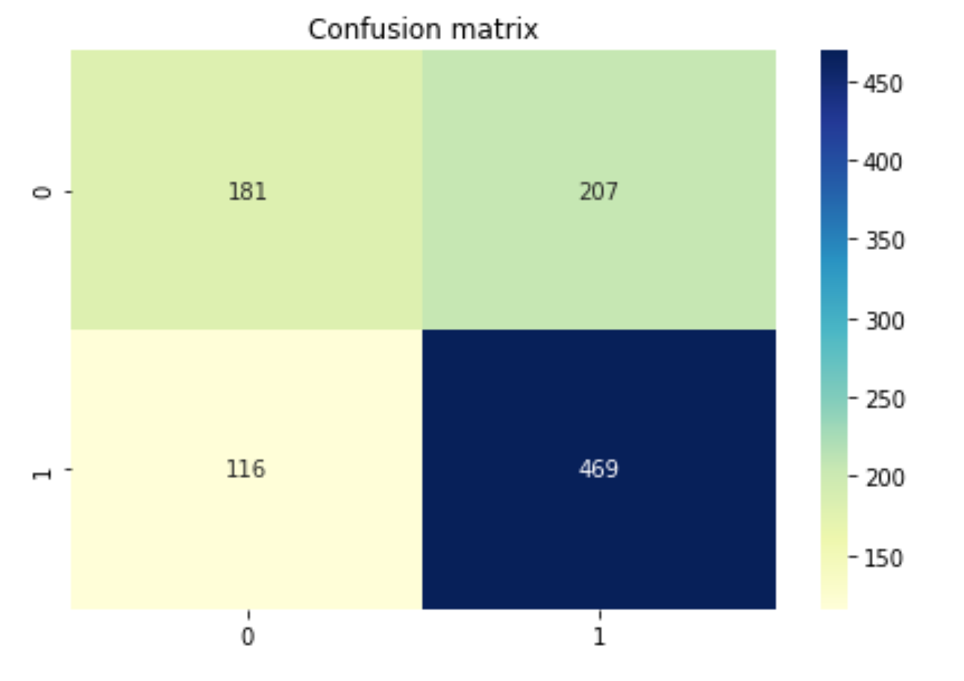

We can see from the confusion matrix, the data has 181 true negative, 207 false positive, 116 false negative and 469 true positive. So it has 181+469 positive predictions and 207+116 false predictions. The accuracy rate is 0.67 which not bad, and precision is around 0.7, recall and f1-score is around 0.67. These rate indicates the model is not perfect but ok.

Also the ROC curve is apart from the red dot line and area under the curve is larger, which means this model predicts overall is good.